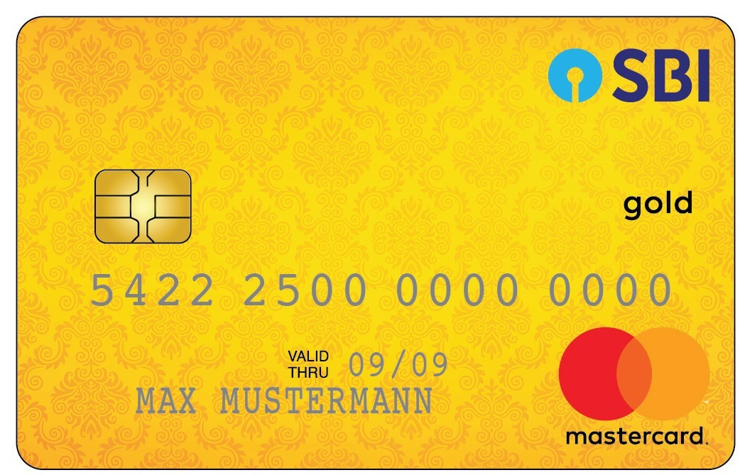

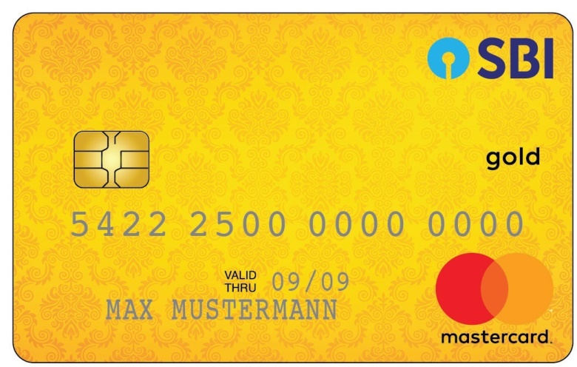 State Bank Gold

DEBIT CARD

2335 4256 4234 2636